Big Love Coffee

Overview

“Big Love” is a fictional company name I assigned to the dataset. A wholesale company that sells coffee beans in kilogram packages to individuals. It comprised coffee bean sales made to customers across three countries over four years. It was, however, a real-life dataset with altered names and addresses to protect client information.

Downloaded from a Github repository, I opened it up on MS Excel, and it had three tables:
- Orders contained information about each coffee bean order made within the period. It had five (5) columns and one thousand (1000) rows. It had two unique identifiers (Customer ID and Product ID) that could connect to the other tables.
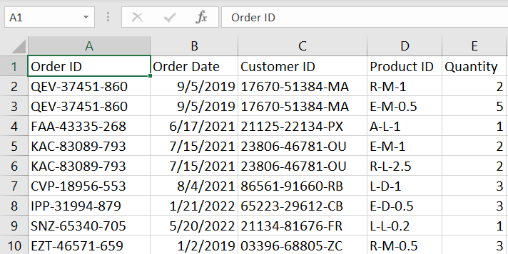
Fig 1.1. Pre-cleaning Orders table showing first ten rows

- Customers: this contained information about each customer who made a coffee bean purchase within the period. It had nine (9) columns and one thousand (1000) rows.
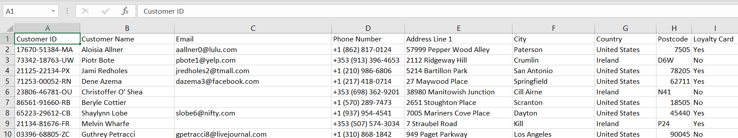
Fig 1.2. Pre-cleaning Customers table showing first ten rows

- Products: It contained information about each coffee bean available during the period. It had seven (7) columns and forty-nine (49) rows.
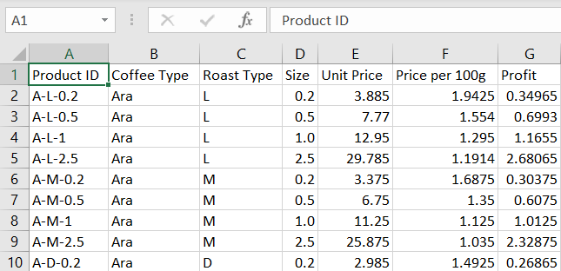
Fig 1.3. Pre-cleaning Products table showing first ten rows

Business Questions

In working on this dataset, I aimed to replicate a real-life scenario where a small-medium scale business could view its year-on-year data and identify key insights for growth and strategy.

After previewing the dataset, I knew I needed to merge the information in the three tables into one, which would be the basis for the dashboard.

I identified the following as key insights that would be valuable to stakeholders within the business:
- Total Sales by Country: The dataset covered three countries, so I could identify the countries generating the most revenue and the gap between them.
- Sales over Time: crucial for every business, I wanted to analyse the sales numbers over the three years of sales to view how profitable the company has been
- Customer Insights: I wanted to view the top purchasing customers and the volume with which they order coffee beans.
- Loyalty: since there was a column showing if each customer had a loyalty card, I decided to check if returning customers had the card and were purchasing in high volumes and if those who did not have the card were one-off customers.
- Product Insights: I wanted to view the product generating the most revenue regarding roast type and bag size.

Data Cleaning

First, I needed to grab all the data from the three tables into one. I started by identifying the data I needed based on the business questions. I created seven (7) columns on the orders table: Customer Name, Country, Loyalty Card, Coffee Type, Roast Type, Size, and Unit Price. Each of the columns was from the other two tables.
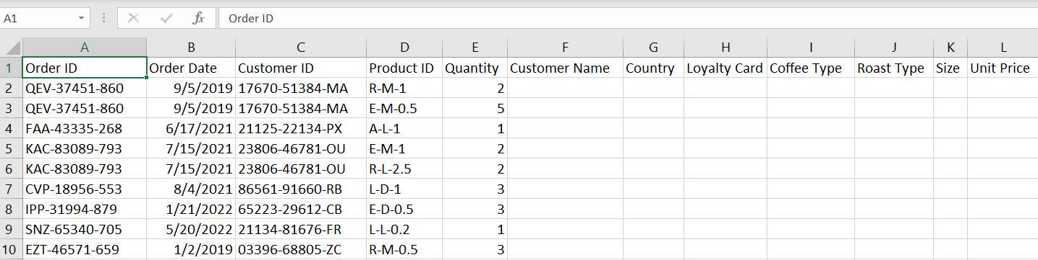
Fig 2.1. Orders table with additional column headers

The first three columns were from the Customer table. I used the XLookup function to bring in the data, with the Customer ID column as the unique identifier.
I repeated the function for the Loyalty Card and Country columns as well. I brought in three (3) columns from the Customer table: Customer Name, Country, and Loyalty Card.

The next columns were from the Products table. Instead of using the XLookup function for each column individually, I used the Index and Match function. Thereby capturing all the columns in one go. I arranged the columns identically to the arrangement in the Products table, so the formula worked effectively. I used the Product ID column as the unique identifier. I brought in four (4) columns from the Products table: Coffee Type, Roast Type, Size, and Unit Price.

I had the data I needed from the tables together on one table. However, I realised I needed extra columns for the analysis. I created three manual columns:
- Sales: I multiplied the Quantity column by the Unit Price column to aggregate the total sale made to each customer
- Coffee Type Full Name: I used the IF function to provide the full names of each abbreviated coffee type (I did a Google search to familiarise myself with the coffee types).
- Roast Type Full Name: I used the IF function to provide the full names of each of the abbreviated coffee types

Finally,
- I formatted the Unit Price and Sales columns to reflect the transaction currency.
- I added the unit (kg) to the Unit Price column
- I set the Order Date column to DD-MMM-YYYY.
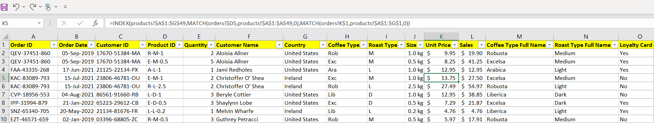
Fig 2.2. Orders table after cleaning

Analysis & Visualizations

To analyse the cleaned table effectively, I had to create pivot tables.
Firstly, I converted the table to an actual table with columns and rows recognised by MS Excel, as evidenced by the Table Design ribbon, which showed up.

I converted the table to a pivot table and started to create pivot tables for analysis, and they include:

- Sales over time: The first pivot table comprised the sum of sales based on each coffee type. This table shows the sales per coffee type for each month of each year within the period. Accompanying the table was a line graph showing the sales trend over the years within the period.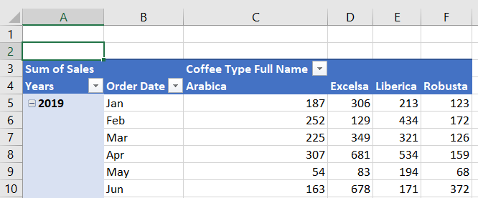
Fig 3.1. Pivot table showing the sum of sales per coffee type

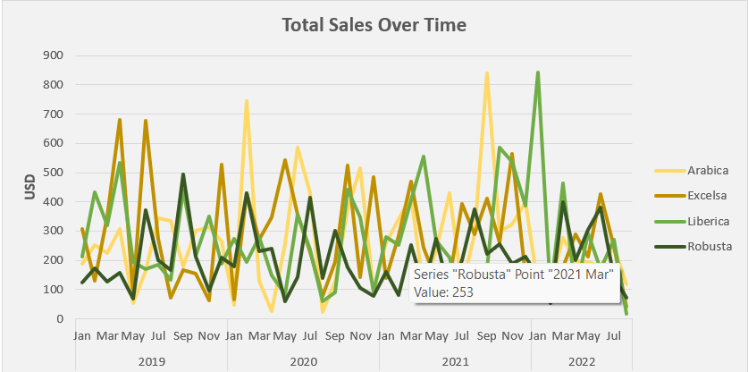
Fig 3.2. Line graph showing coffee type vs. sum of sales over time

- Sales By Country: The second pivot table comprised the sales per country within the period. Accompanying the table was a bar chart that displayed the country on the y-axis versus the sum of sales on the x-axis.
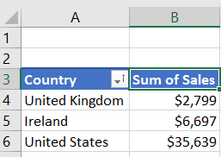
Fig 3.3. Pivot table showing the sum of sales per country
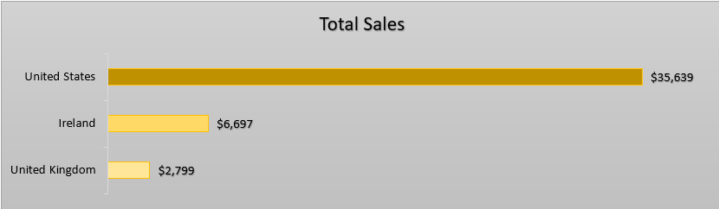
Fig 3.4. Bar chart showing the sum of sales per country in descending order

- Sales By Customer: The third pivot table was created based on the sum of sales per customer. Accompanying the table was a bar chart which showed the top five (5) purchasing customers in descending order. Shout-out to Allis!
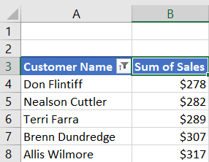
Fig 3.5. Pivot chart showing the sum of sales per customer
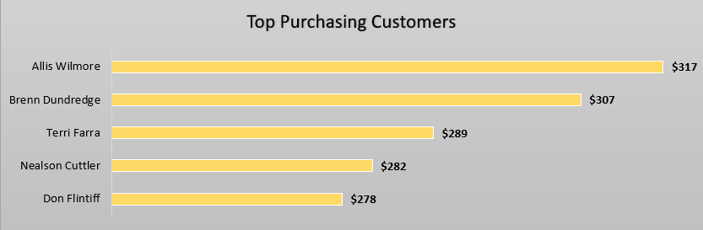
Fig 3.6. Bar chart showing the sum of sales per customer in descending order

- Timeline and Filters: I created the dashboard to be dynamic and give the end-user options to filter for desired data; this meant adding filters and a timeline to drill down for specific information and select specific periods, respectively. I created three (3) filters: Roast Type, Size, and Loyalty Card. I made the timeline to cover the period of the data.
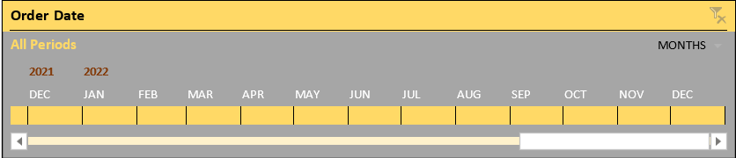
Fig 3.7. Sales timeline showing Dec 2021 to Dec 2022
Fig 3.8. Three filter cards for roast type, size, and loyalty card

Insights & Conclusions

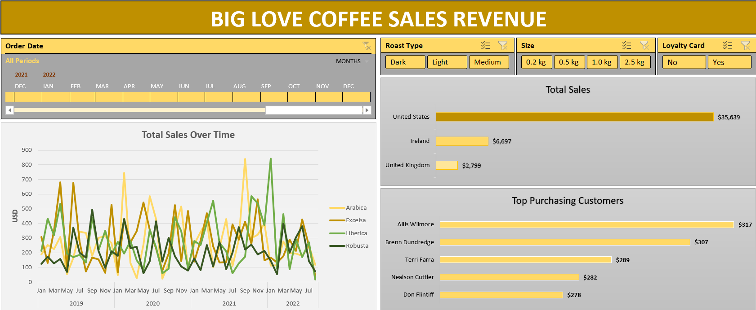
Fig 4.1. Final dashboard containing all visualisations

- By a considerable degree, the United States racked up the most sales, and it was obvious that “Big Love Coffee” was located in the United States of America.
- 2019 had sales fluctuate between the $100 - $400 mark, with June being the most profitable, hitting $681.
2020 started strong in Q1, with February recording the highest sales at $745. This, however, fluctuated throughout the year, with August & September having a major decline before recovering in October.
2021 saw sales gradually increase throughout the year. Q4 was the most successful, with sales between $150 and $600; September recorded the highest sale of $841.
2022 had consistent numbers between the 200 - 400 mark. However, the data cut off in August. There was a sharp decline in February, recording the lowest sale of the year at $91, just after January recorded a year-high $844.
- Allis Wilmore was the top purchasing customer, with $317 spent over the four years. Interestingly, they only made purchases three times within this period, each with a high volume. The rest of the top five racked up numbers within touching distance of each other. The difference between the first and fifth was $39.
- Four of the customers within the top 5 purchasing customers did not have a loyalty card; only Ben Dundregde had one and, unsurprisingly, had made a purchase the most times as well.
- The 2.5kg bag was the top-selling bag. It had twice the amount sold in the United States than the second sold bag, the 1.0kg bag.
The Roast Type sales were similar. The Light roast type accumulated the most sales, followed by the Medium kind and then the Dark.

